FACTORY SIMULATION — FINAL REPORT
OOP with C++ GIST EECS

1. Team Information
Team name | BBANG
Factory domain | Smart Farm Bakery
GitHub repository | https://github.com/eh-rud/BBANG.git

Member | Student ID | Primary responsibility
김도경 | 20255021 | Leader & Frontend Architecture & Interface Design (Developing Dear ImGui UI layouts, prototyping View layers, and implementing UI-to-Controller Command/Snapshot DTO bindings)
황서현 | 20255243 | Backend Core Logic & State Machine (Designing the Factory Simulation Object hierarchy, implementing concrete machine process timers, and managing core update loops)

2. Class Inventory
Class name | Layer (Model/View/Controller) | Abstract / Concrete | Inherits from | Status
SimulationObject | Model | Abstract | - | Done
Machine | Model | Abstract | SimulationObject | Done
ProducerMachine | Model | Abstract | Machine | Done
ProcessorMachine | Model | Abstract | Machine | Done
ConsumerMachine | Model | Abstract | Machine | Done
FarmGrower | Model | Concrete | ProducerMachine | Done
MillMachine | Model | Concrete | ProcessorMachine | Done
DoughMixer | Model | Concrete | ProcessorMachine | Done
Oven | Model | Concrete | ProcessorMachine | Done
Packager | Model | Concrete | ProcessorMachine | Done
DeliveryTruck | Model | Concrete | ConsumerMachine | Done
Worker | Model | Abstract | SimulationObject | Done
Technician | Model | Concrete | Worker | Done
Product | Model | Abstract | - | Done
RawMaterial | Model | Concrete base class | Product | Done
IntermediateProduct | Model | Concrete base class | Product | Done
FinishedGood | Model | Concrete base class | Product | Done
WheatProduct | Model | Concrete | RawMaterial | Done
FlourProduct | Model | Concrete | IntermediateProduct | Done
DoughProduct | Model | Concrete | IntermediateProduct | Done
BreadProduct | Model | Concrete | FinishedGood | Done
ParcelProduct | Model | Concrete | FinishedGood | Done
FarmPlot | Model | Concrete | - | Done
StorageBin | Model | Concrete | - | Done
OrderItem | Model | Concrete | - | Done
EventItem | Model | Concrete | - | Done
Factory | Model / Controller | Concrete | - | Done
QueueInfo | Model / View DTO | Struct | - | Done
FactoryCommand | Controller / View DTO | Struct | - | Done
FactorySnapshot | Model / View DTO | Struct | - | Done
PlotSnapshot | Model / View DTO | Struct | - | Done
StorageSnapshot | Model / View DTO | Struct | - | Done
OrderSnapshot | Model / View DTO | Struct | - | Done
EventSnapshot | Model / View DTO | Struct | - | Done
MachineSnapshot | Model / View DTO | Struct | - | Done
TruckLoadSnapshot | Model / View DTO | Struct | - | Done
UIState | View | Struct | - | Done
Theme | View | Namespace / UI helper module | - | Done
UI | View | Namespace / reusable UI component module | - | Done
frontend.cpp module | View | Module | - | Done
UI_Core.cpp module | View | Module | - | Done
UI_Scenes.cpp module | View | Module | - | Done
main.cpp module | Controller / Application | Module | - | Done
ZoneTab | View / Model | Enumeration | - | Done
PlotState | Model | Enumeration | - | Done
MachineState | Model | Enumeration | - | Done
Scenario | Model / Controller | Enumeration | - | Done
ItemType | Model | Enumeration | - | Done
EventType | Model | Enumeration | - | Done

3. Final Class Diagrams and Architecture Diagrams

1. Backend Core Inheritance UML
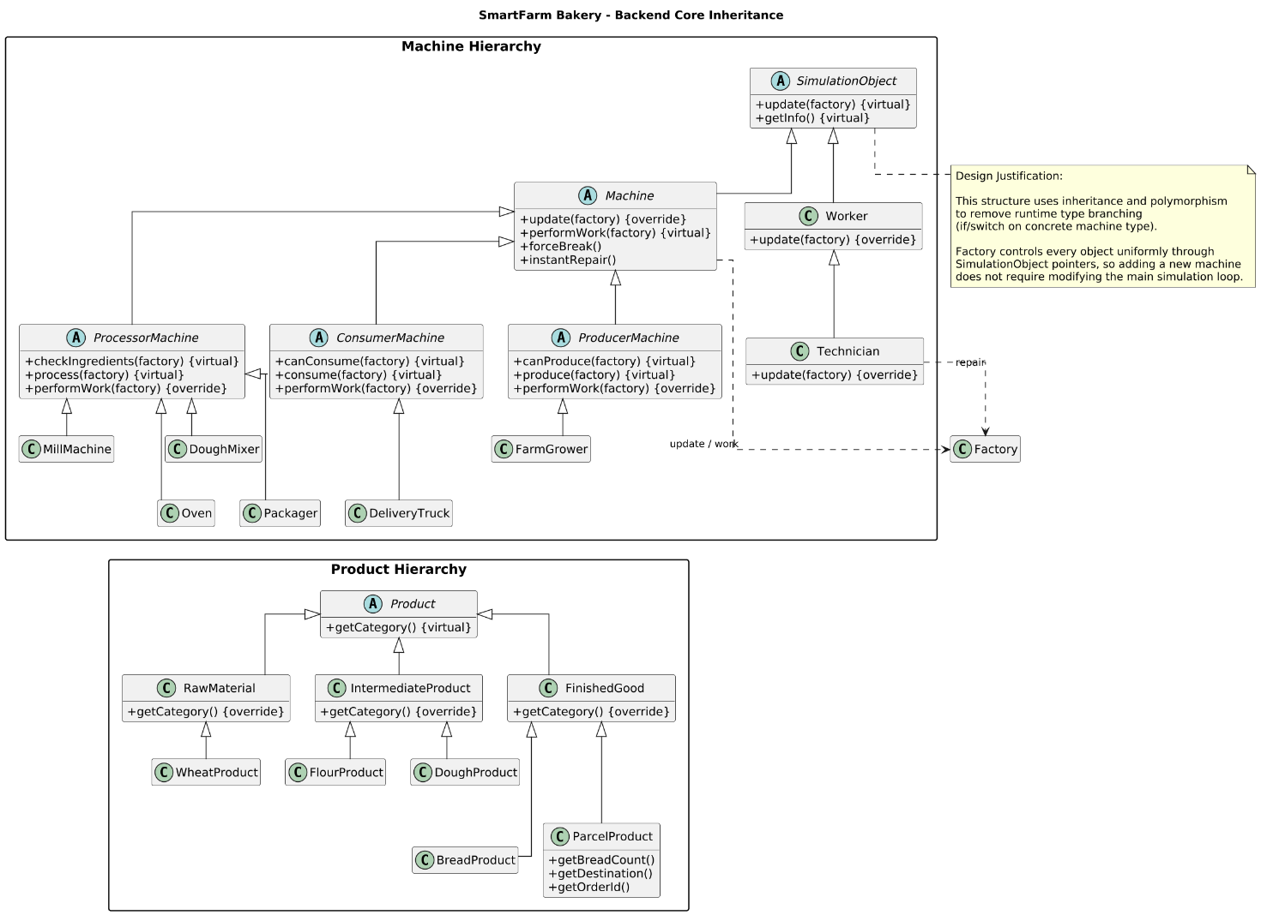
A class hierarchy of machines and products that achieves perfect polymorphism by utilizing SimulationObject as the base class, completely eliminating runtime type branching (if/switch statements).
2. Backend Factory Composition UML
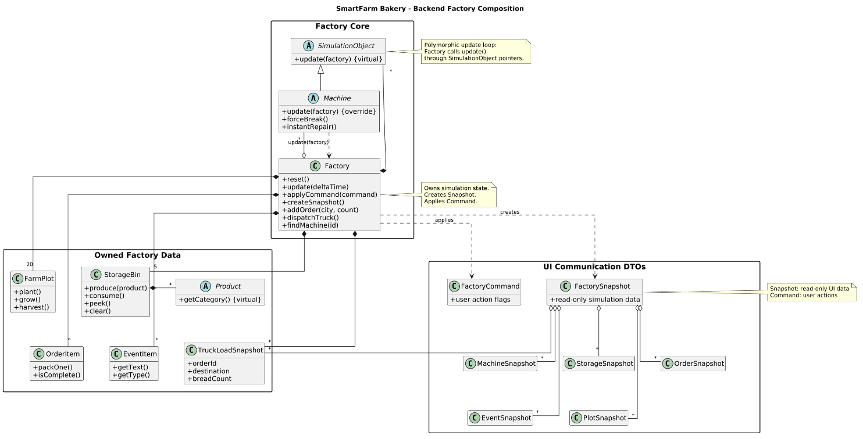
An architectural view illustrating how the Factory core centrally manages the simulation state and owned data, while generating read-only Snapshot and write-only Command objects to communicate with the UI.
3. Frontend/UI Overview UML
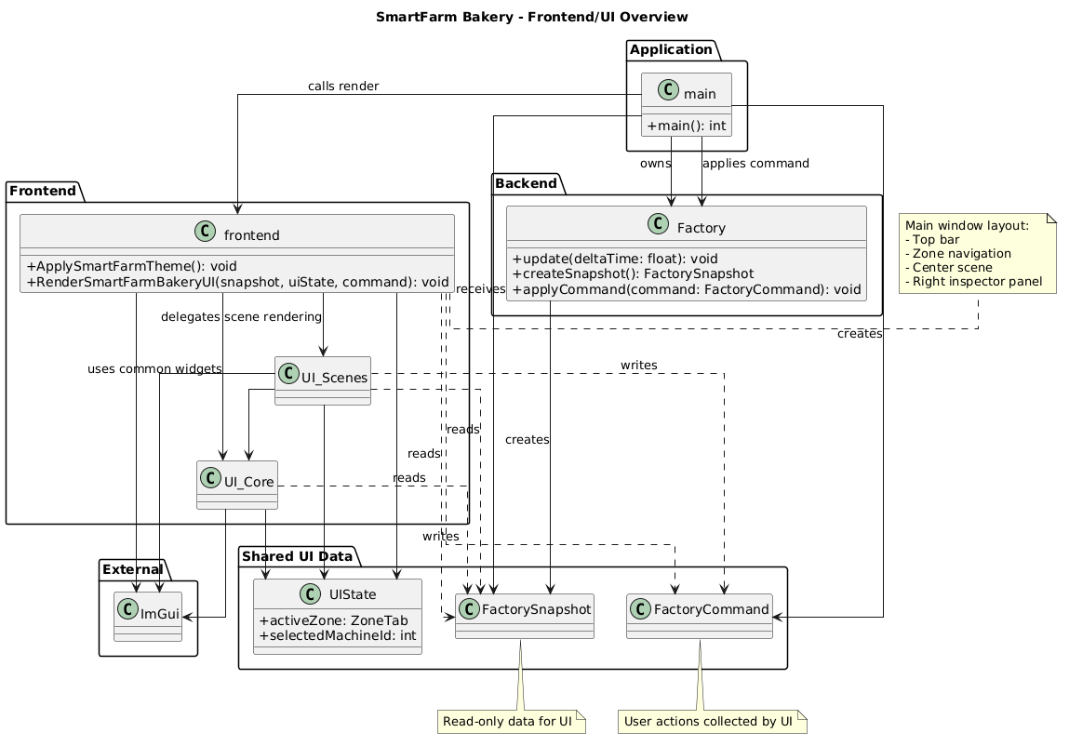
A modular rendering architecture completely isolated from the business logic, utilizing ImGui and reusable components (UI_Core) to visualize simulation data and capture user commands.
4. Full Project Overview UML
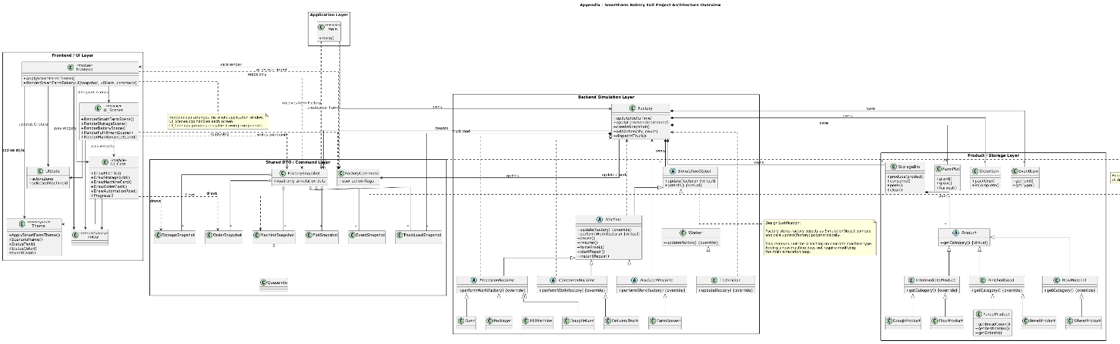
A comprehensive blueprint of the system demonstrating loose coupling between the application (main), frontend, backend, and data layers via Data Transfer Objects (DTOs) without direct dependencies.

4. UI Screenshots

- Initial screen of the SmartFarm Bakery simulation before any action is taken, showing the default dashboard, control panel, inspector, and event log.
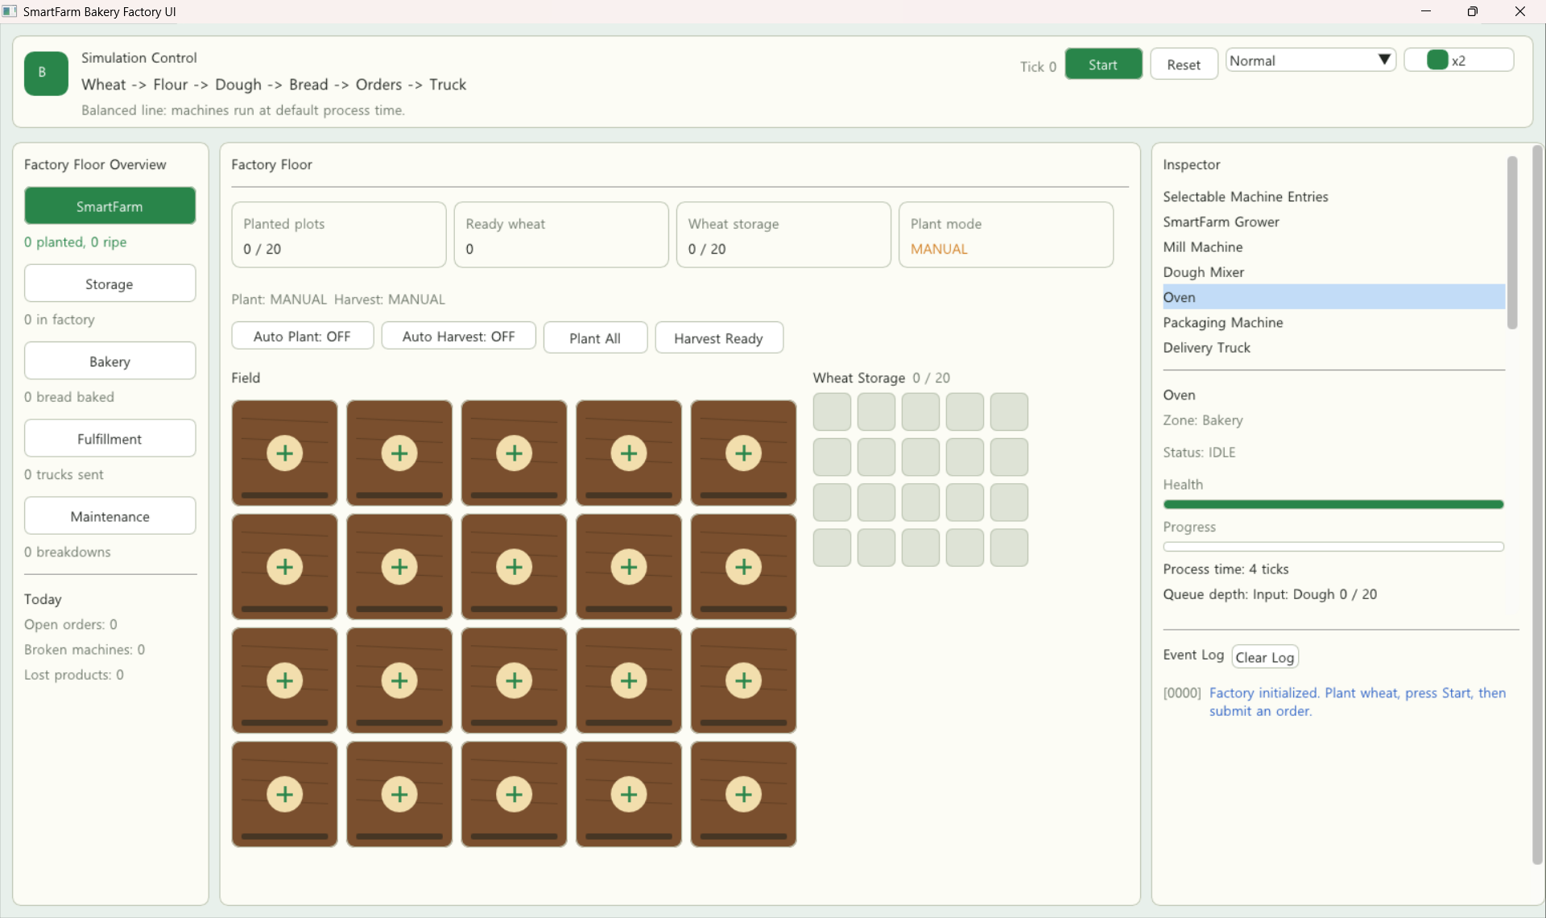

- SmartFarm view after planting seeds and harvesting wheat, showing plot growth status and harvested wheat stored in Wheat Storage.
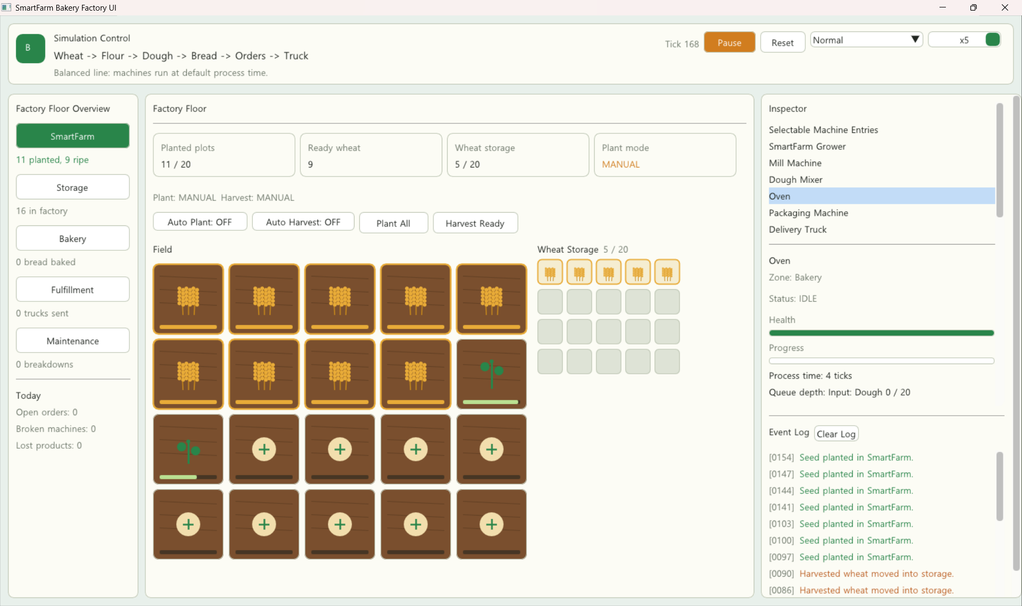

- Bakery view showing the production flow in which harvested wheat is processed by the Mill Machine, Dough Mixer, and Oven into flour, dough, and bread.
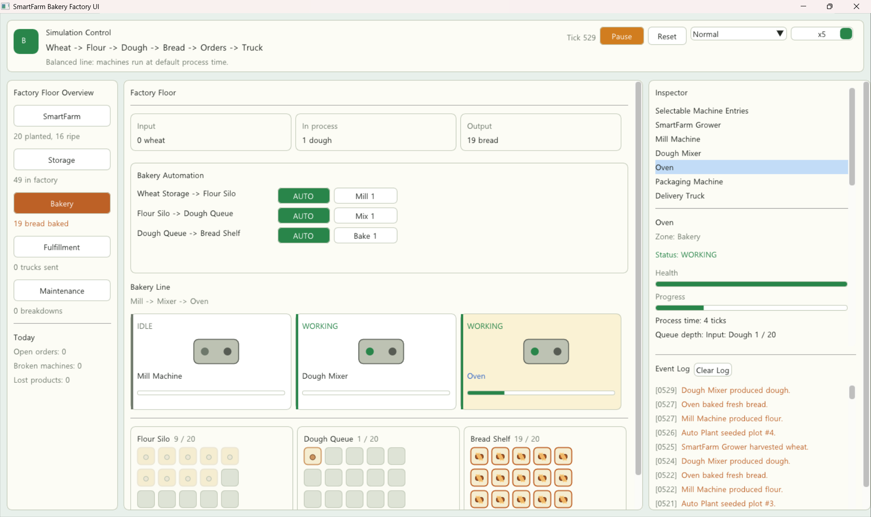

- Fulfillment view after multiple customer orders have been entered, displaying the active order list and fulfillment control panel.
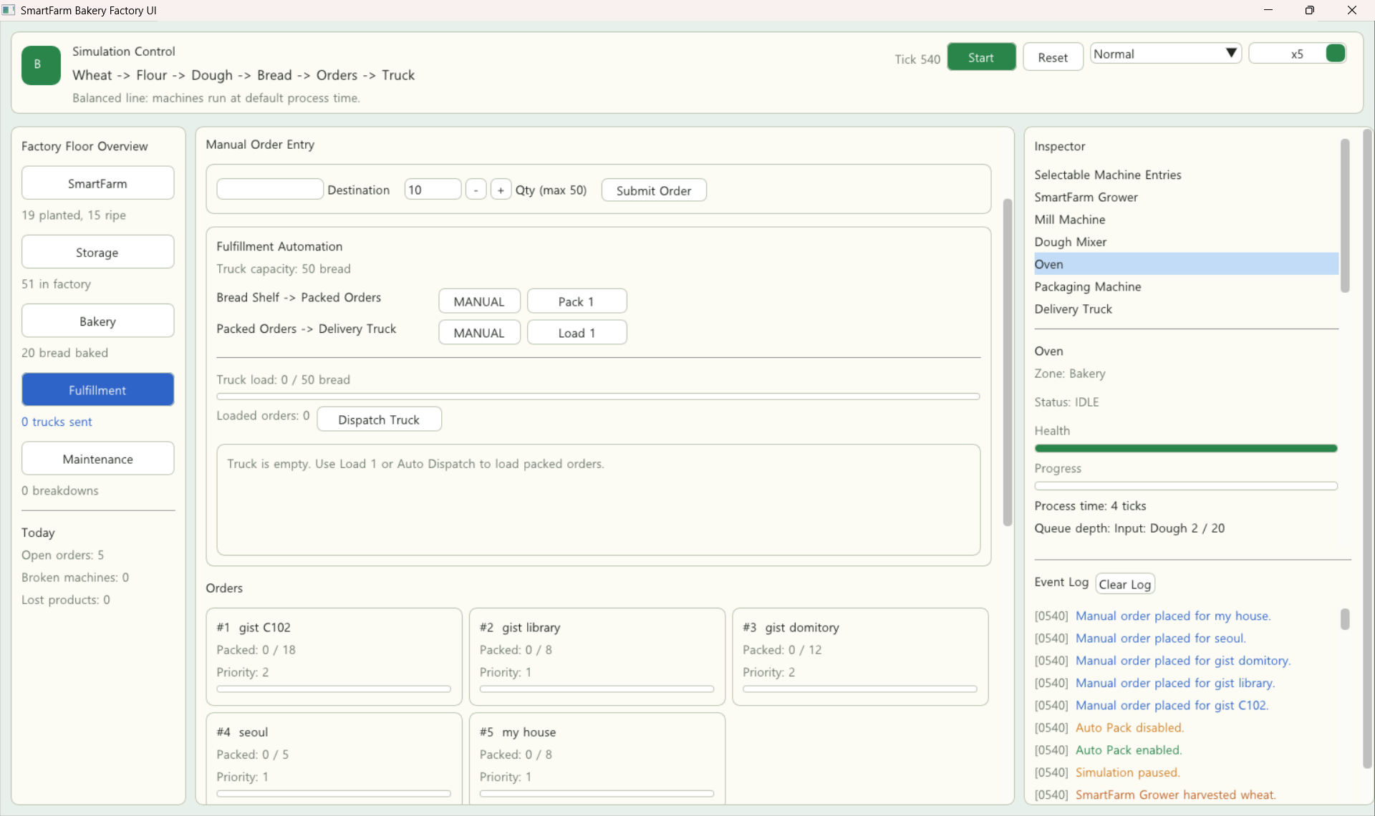

- Fulfillment process in which the Packaging Machine packs bread according to incoming orders and stores completed packages in Packed Orders.
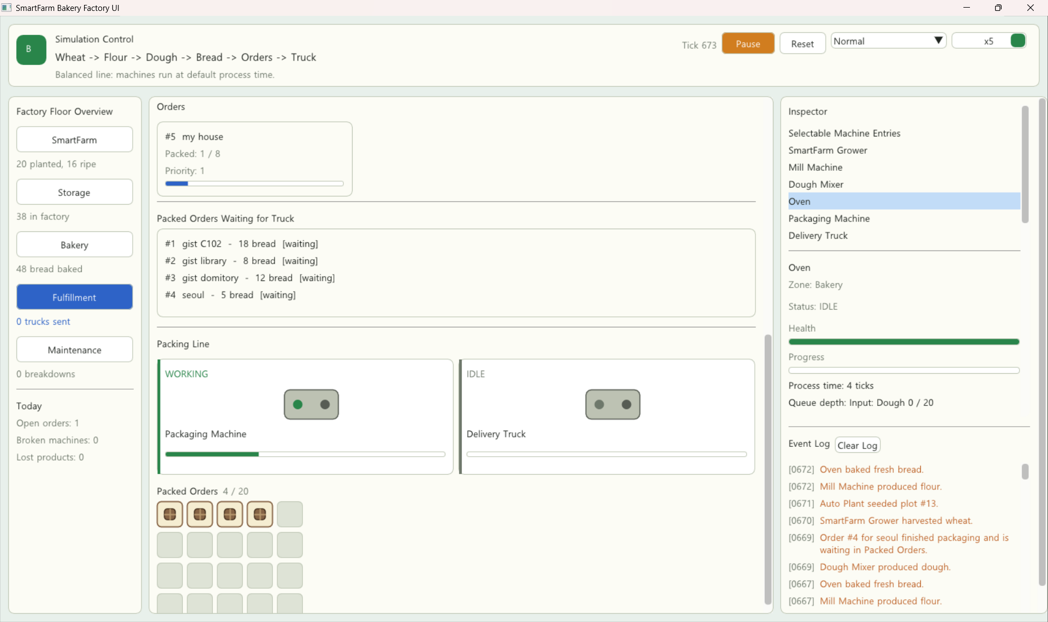

- Fulfillment view showing packed orders loaded onto the Delivery Truck before dispatch.
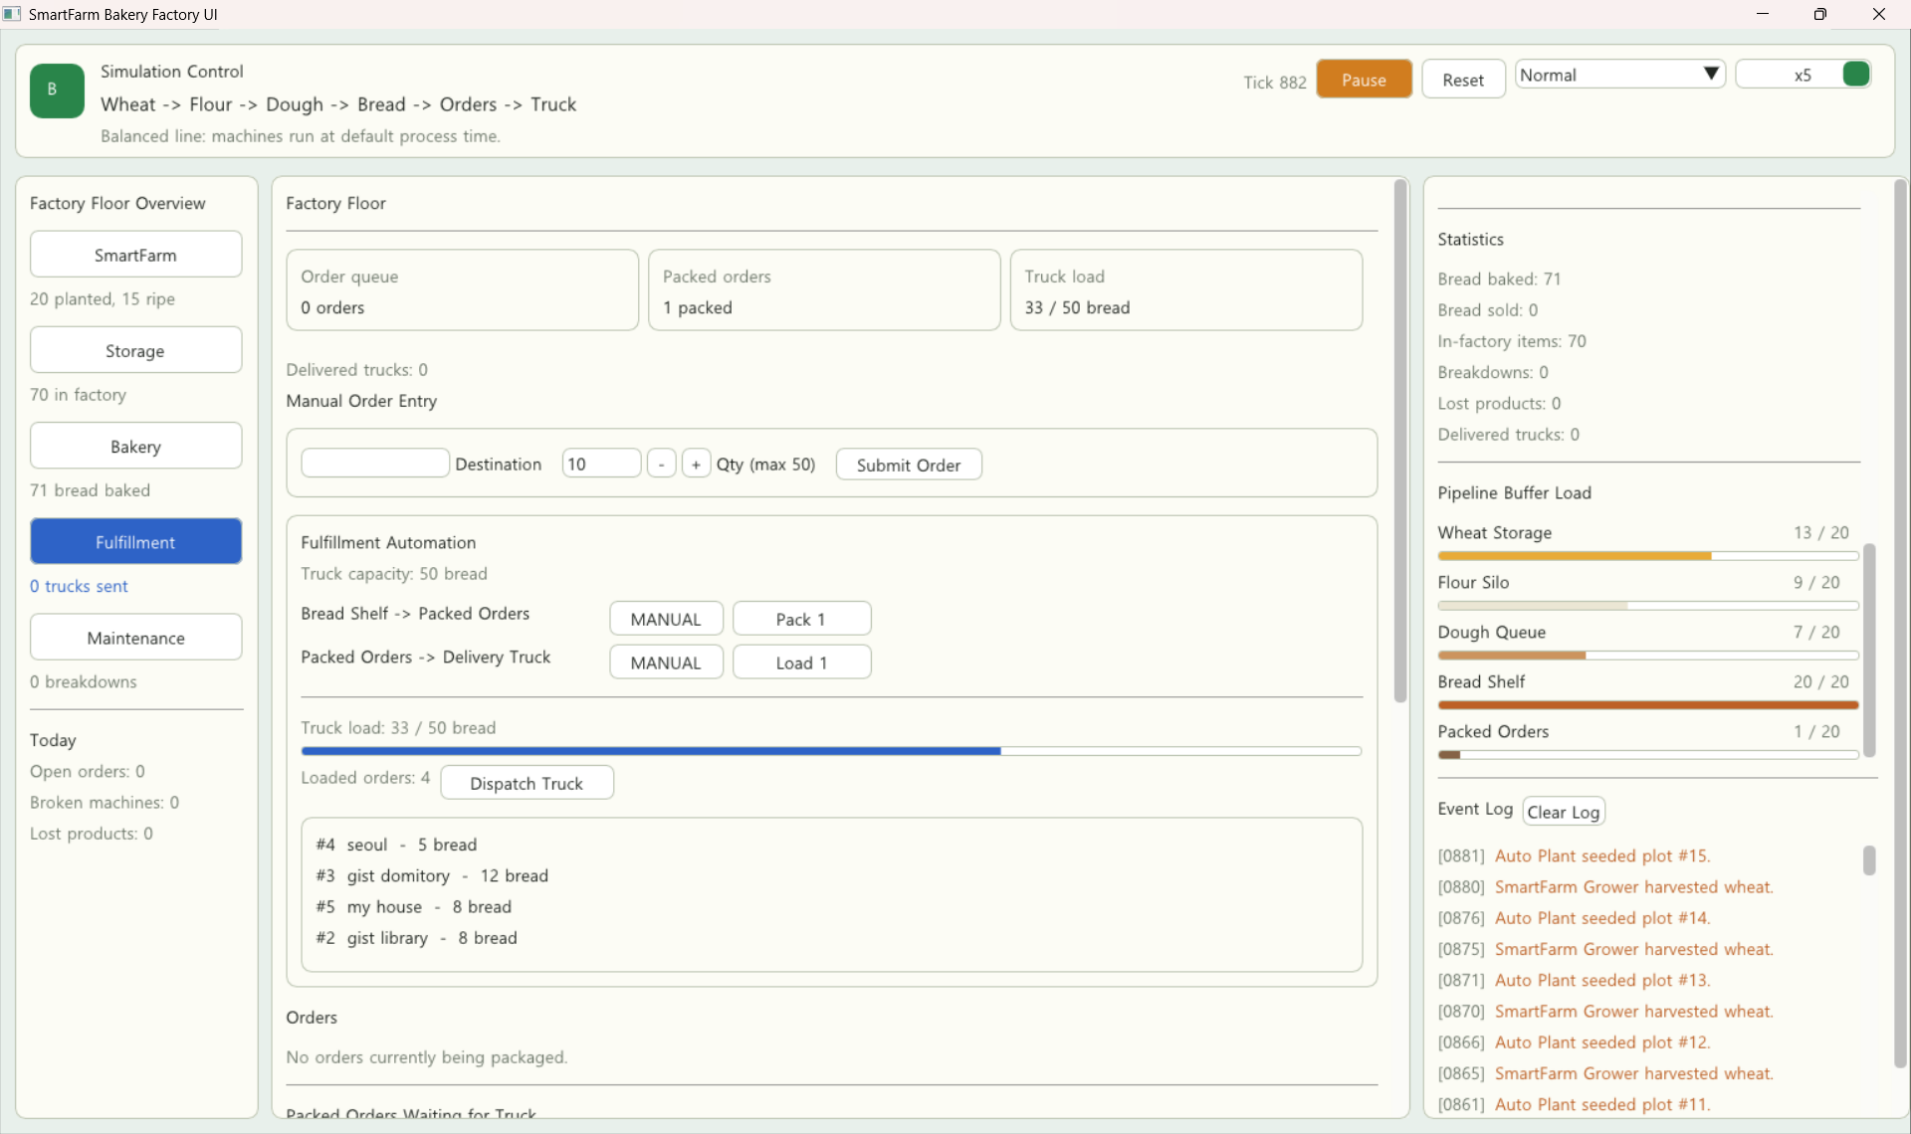

- Fulfillment view after truck dispatch, showing the increased number of sold bread and delivered trucks.
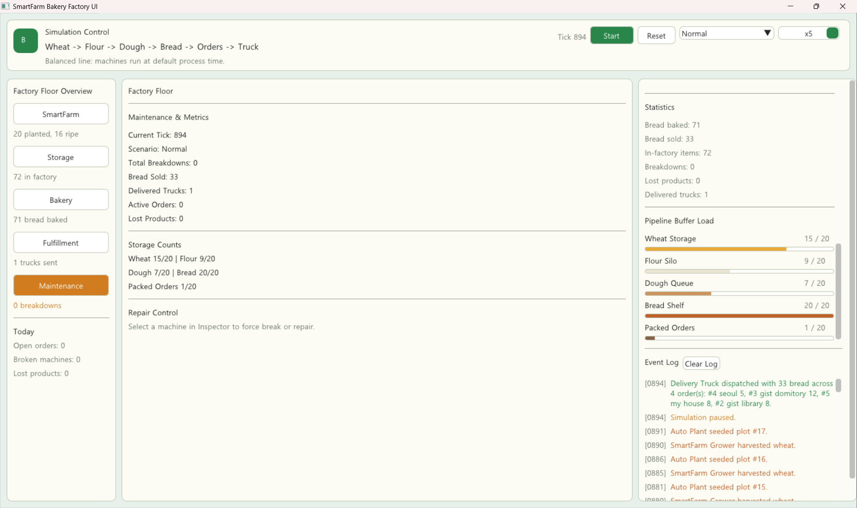

- Storage view displaying the current inventory status of Wheat Storage, Flour Silo, Dough Queue, Bread Shelf, and Packed Orders.
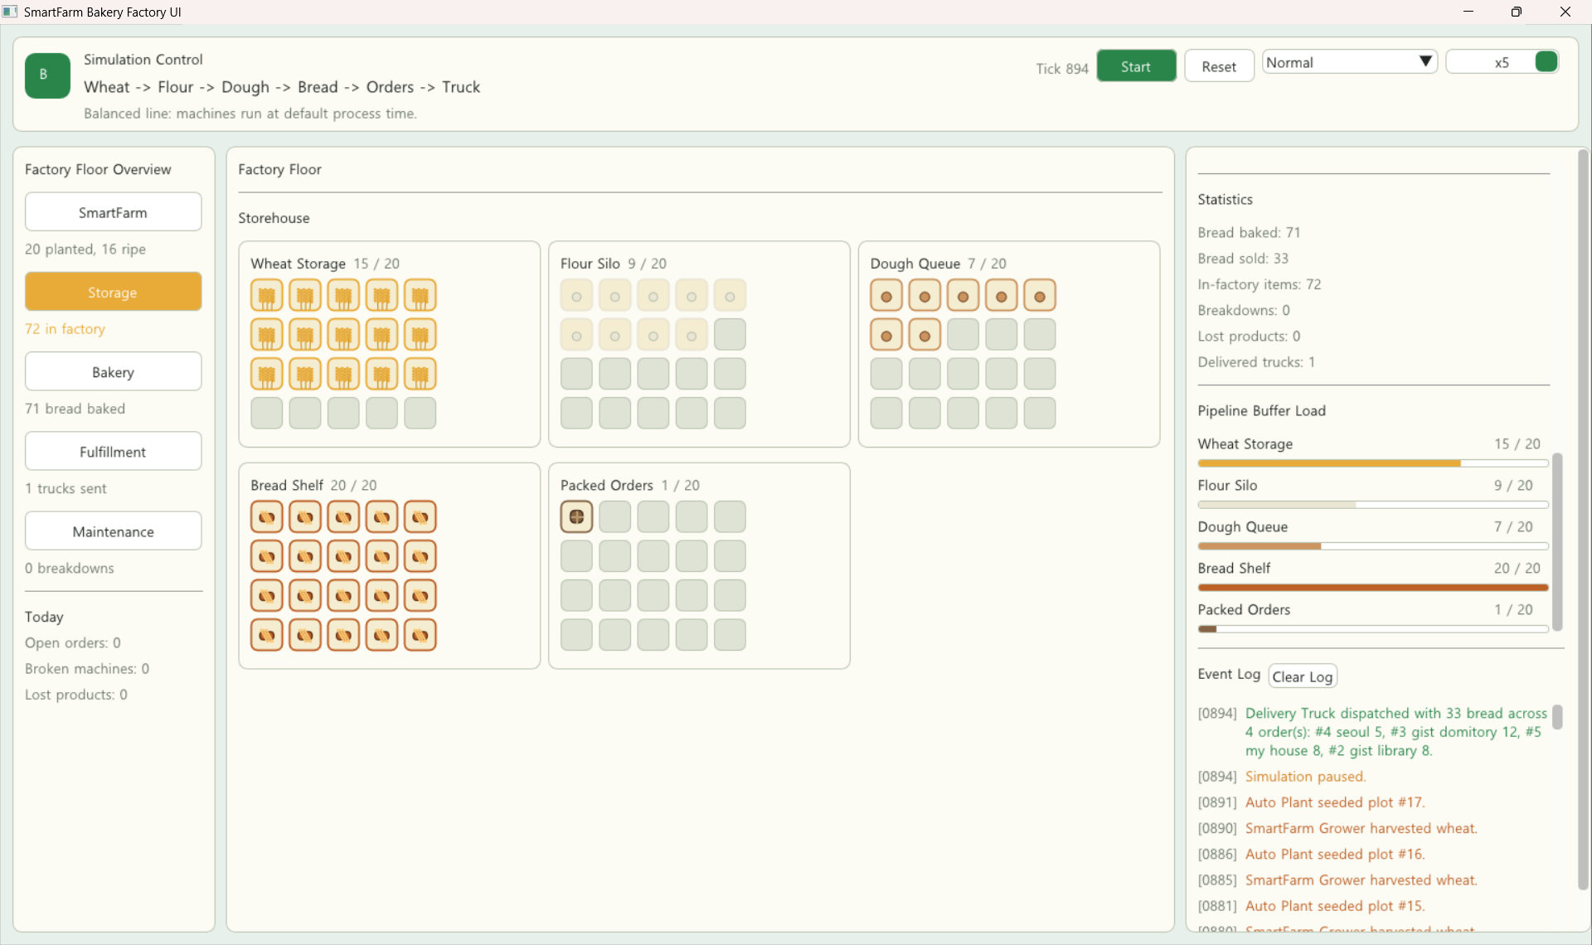

- Maintenance scenario in which machines are forcefully broken and a technician is dispatched to repair the damaged machine.
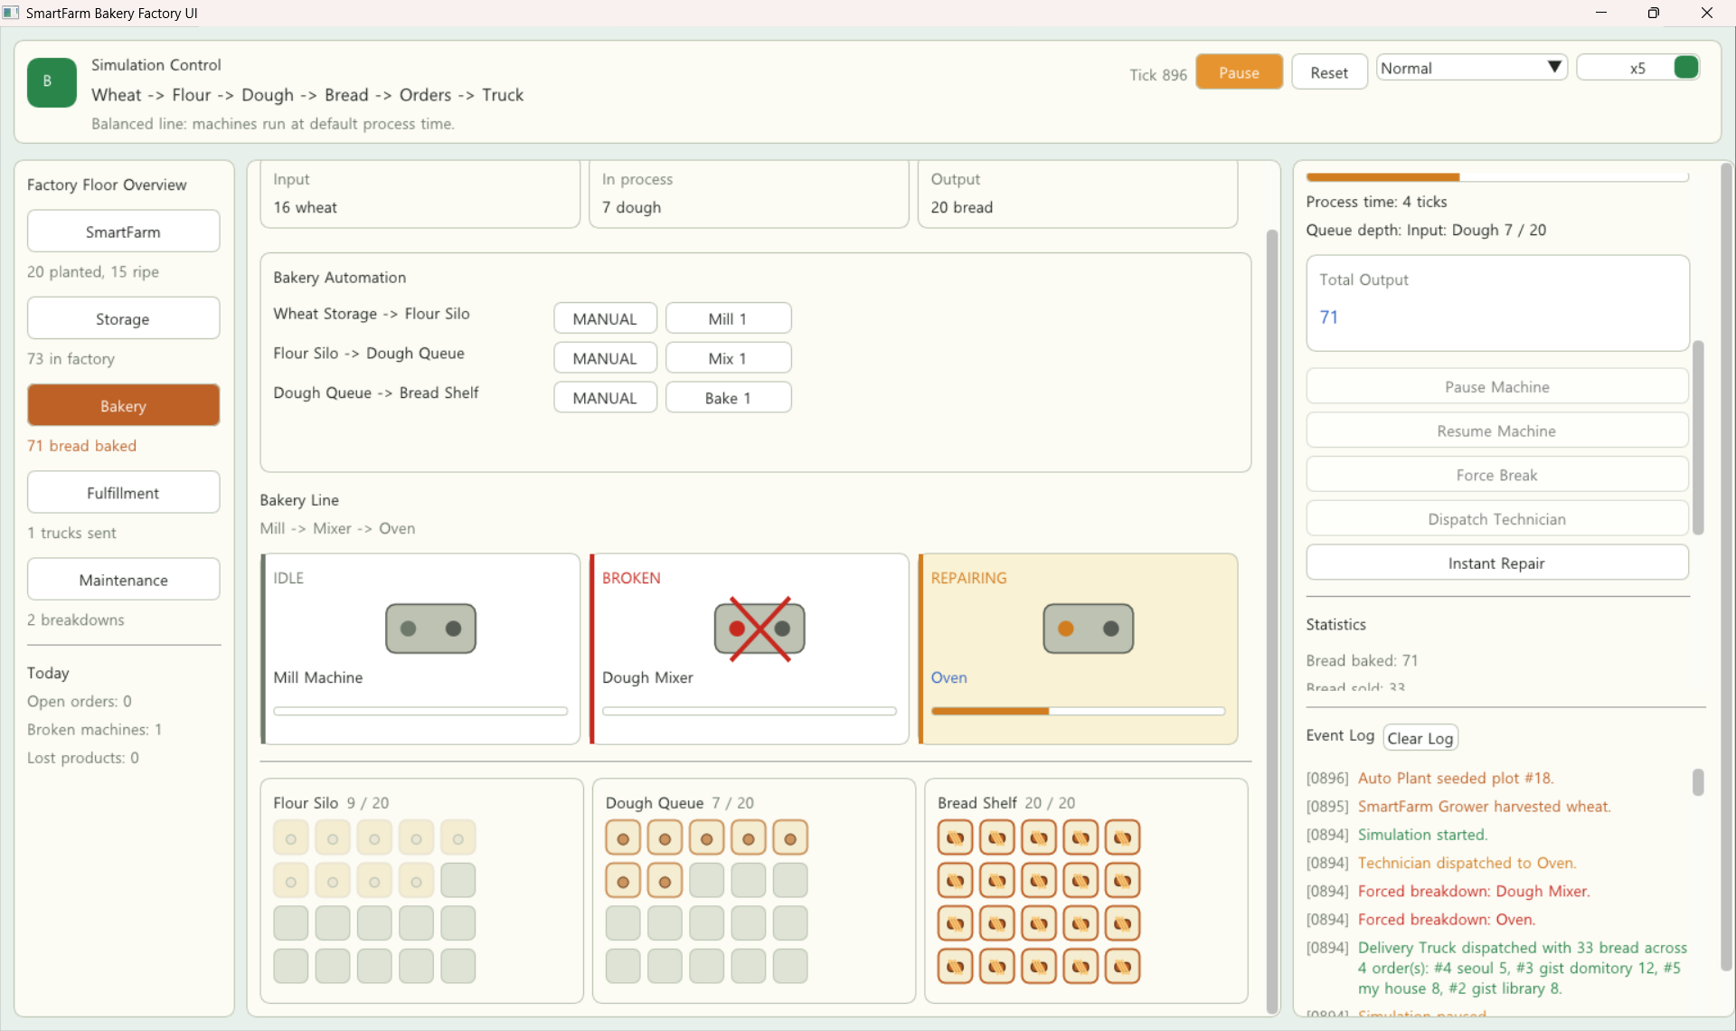

5. Project Completion Roadmap

# | Task | Owner | Target date | Done?
1 | Finalize backend class hierarchy using SimulationObject, Machine, ProducerMachine, ProcessorMachine, ConsumerMachine, and concrete machines. | 황서현 | May 24 | ■
2 | Implement product hierarchy and storage/order model using Product, StorageBin, OrderItem, and EventItem. | 황서현 | May 24 | ■
3 | Implement Factory update loop, command handling, and snapshot generation. | 황서현 | May 24 | ■
4 | Implement Dear ImGui frontend layout with Simulation Control, Factory Floor, Inspector, Event Log, and Statistics panels. | 김도경 | May 26 | ■
5 | Implement FactoryCommand and FactorySnapshot DTO flow for frontend/backend separation. | 김도경 | May 28 | ■
6 | Implement bakery production pipeline: wheat, flour, dough, bread, packed orders, and delivery truck. | 황서현 | May 30 | ■
7 | Implement scenarios: Normal, Bottleneck, Breakdown Manual, Breakdown Auto, and Overflow. | 황서현 | June 1 | ■
8 | Integrate UI controls with backend simulation actions and machine inspector controls. | 김도경 | June 3 | ■
9 | Test final demo flow, including order fulfillment, truck dispatch, breakdown, and technician repair. | 김도경 | June 5 | ■
10 | Finalize UML diagrams, screenshots, report, GitHub repository, and presentation materials. | Joint | June 6 | ■

6. Instructor Feedback
Progress rating | □ On track □ Minor delays □ At risk □ Needs discussion
Architecture check | □ Frontend / backend correctly separated □ Needs revision
UML quality | □ Satisfactory □ Incomplete □ Incorrect — resubmit
Comments
Date reviewed

